
SECRET
FUNCTION INTRODUCTION
Function management
Function Name: |  | Comfort Stop
Function Mapping: |  | Driver assistance, autonomous driving, and chassis management
Function: |  |  |  | Function-ID:
 | Name |  | Roler | Date | signature
Create/Modify:
check:
Approve OMK:

1 Function Introduction 4
1.1 Function description 4
1.2 Function partner list 4
1.3 Function action mode diagram 4
2 System Architecture 5
2.1 Function architecture 5
2.2 Sub-function list 6
2.3 Description of function interface 6
2.3.1 System dependency (Signals Interaction) 6
2.3.2 Hardware Interface 7
3 Basis function specification 8
3.1 Description of the function status 8
3.2 Logical signals of function 8
3.3 Base Parameters of function (calibration range) 9
3.4 State interpretation and diagram 10
3.5 Diagnostic requirements 10
3.5.1 Special Control Modes 10
3.5.2 Partial System Shutdown Modes 10
3.6 Edge conditions 10
4 Major Additional Function 10
5 Special States Detect 11
6 Functional safty 11
6.1 Hazard and Risk analysis 11
6.2 Functional safety concept 11
6.2.1 Degradation Mode 11
7 Regulatory Requirements 11
8 Function Dependencies 11
8.1 Internal 11
8.2 Extra 12
8.2.1 Self-checking strategy 12
8.2.2 Function Active Display Strategy 12
8.2.3 Fault Display Strategy 12
9 Special Performance Requirements 12
10 Appendix A 12
10.1 Change History 12

Function Introduction

Function description
CST(Comfort Stop), some times called PRB(Pitch Reduction Brake), The function is designed to provide the driver with a smooth feel when the car is slowing to a standstill, eliminating or minimizing the longitudinal pitch or jerk of the vehicle when it comes to a stop. It implements this by controlling the brake pressure on all four wheel.
The default status of CST switch is on when the vehicle is powered up for the first time after vehicle offline.
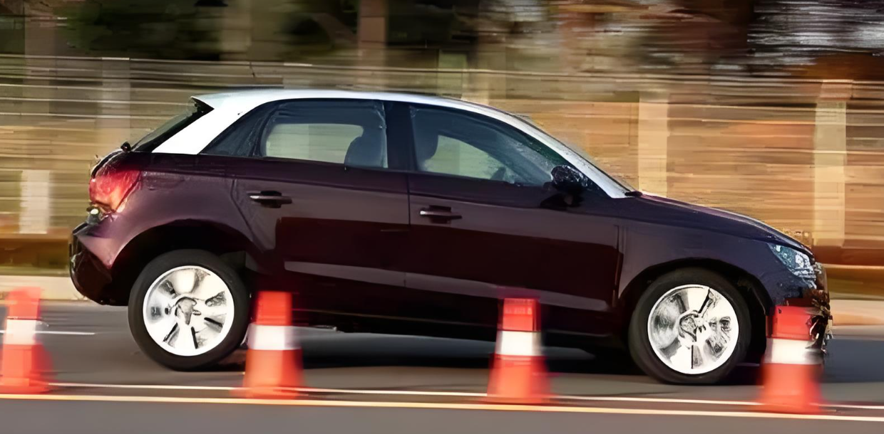
Figure1. Comfort Stop

Function partner list
- iBRS
- Wheel Speed Sensor
- IMU
- LDCU

Function action mode diagram
The function ' Comfort Stop ' calculates a request for the hydraulic brake system to control the hydraulic brake force in wheel side.
The diagrams are based on ZF IBC (Integrated Brake Controller) system

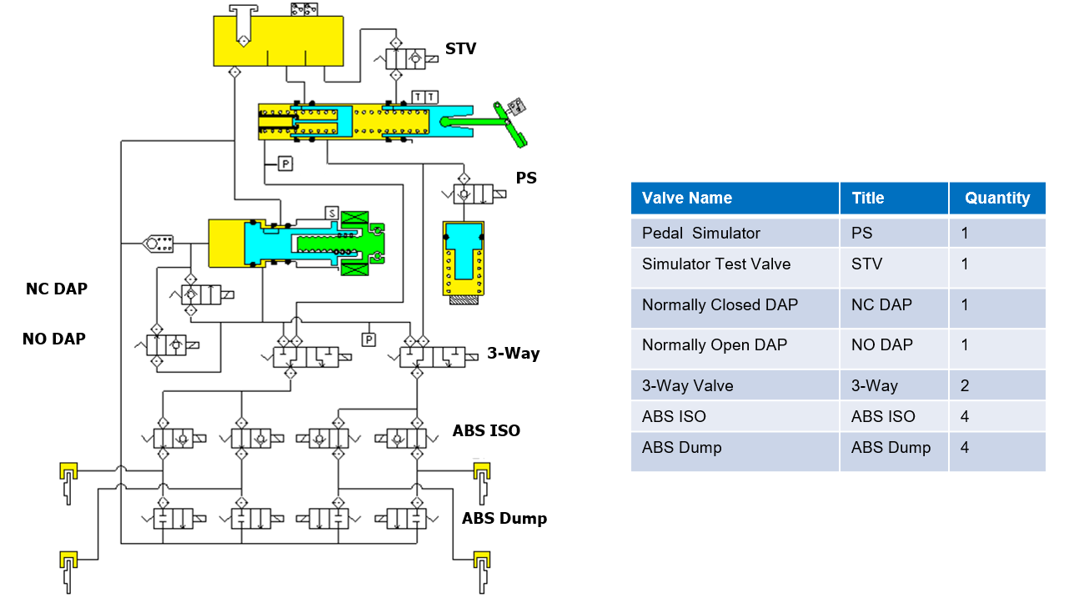
Figure2. Hydraulic Schematic

System Architecture

Function architecture
The CST function is designed to give the driver a smooth feeling when braking in non-emergency situations, decelerating to a standstill by applying less brake pressure than the driver requires. When the vehicle is at a standstill, the CST function increases the brake pressure to the driver's requested.

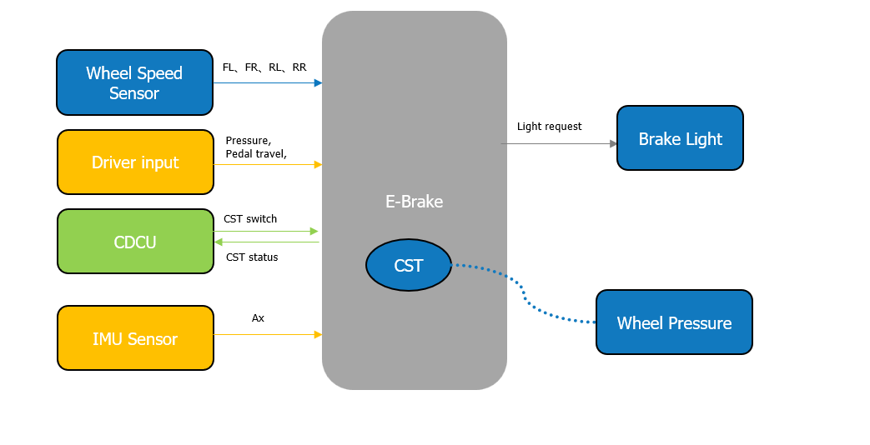

Figure 3. CST system architecture

Sub-function list
NA.

Description of function interface

System dependency (Signals Interaction)
The following table lists the interactive signals for CST function. The names in the table are from VW CMP21D CEA2.0 version Comms matrix “IBRS_CEA2_CAN_MATRIX”.
Signal Name | Sender | Tx/Rx | Cycle | Unit | Range | ASIL Level | Description
CDCU_CST_OFF_Switch | CDCU | RX | 100ms | Enum | 0x0: No command  0x1: ON  0x2: OFF  0x3: Reserved | QM | CST Request
LDCU_AccPedalSig | LDCU | Rx | 10ms | % | 0-100 | ASIL C | Accelerator pedal position signal
LDCU_AccPedalSigVD | LDCU | Rx | 10ms | Enum | 0x0:Not valid;  0x1:Valid; | ASIL C | LDCU_Accelerate Pedal Signal Valid
LDCU_GearLev | LDCU | Rx | 10ms | Enum | 0x0: Invalid;  0x1: D gear;  0x2: N gear;  0x3: P gear;  0x4:P gear;  0x5-0x7:Reserved | ASIL B | LDCU_Gear Level
IPB_VehLongAccel | IMU | Rx(Private) | 10ms | g | -1.73 – 1.73 | ASIL B(D) | Longitudinal Acceleration
IPB_VehLongAccelVD | IMU | Rx(Private) | 10ms | Enum | 0x0: Not valid;  0x1: valid; | ASIL B(D) | The valid of longitudinal acceleration
IPB_CST_Status | IBRS | TX |  | Enum | 0x0: CST is disabled_ Init_Default  0x1: CST is Standby  0x2: CST is Active  0x3: CST is Failure | ASIL A | CST Request Valid
IPB_BrkLightOnReq | IBRS | Tx | 20ms | Boolean | 0x0: Off;  0x1: On; | ASIL B | Break Light On Request
IPB_BrkLightOnReq_E2E | IBRS | Tx | 20ms | Boolean | 0x0: Off;  0x1: On; | ASIL B | Break Light On Request,E2E

Hardware Interface
Name | Type
KL15 | Hardwired
KL30 | Hardwired
Left front wheel speed sensor | intelligent
Right front wheel speed sensor | intelligent
Left rear wheel speed sensor | intelligent
Right rear wheel speed sensor | intelligent
IBC CAN(H、L) | Hardwired

Basis function specification

Description of the function status
In daily driving, the pitch caused by vehicle braking can easily cause users to feel uncomfortable. Under the premise of ensuring safety and sense of security, the CST function will help reduce driving fatigue and improve the comfort of passengers.
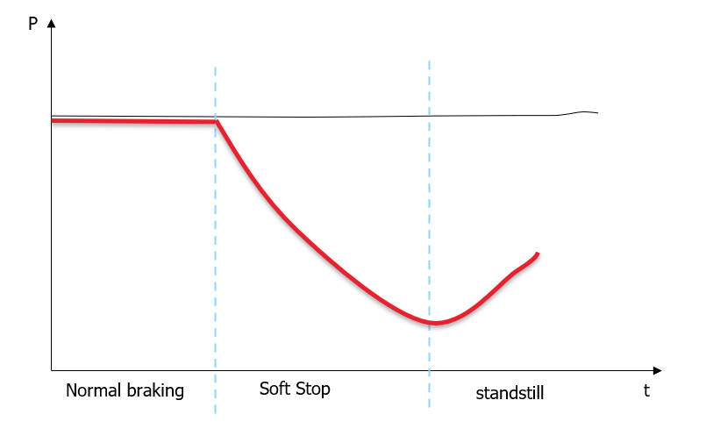
Figure 4. CST Working Schematic Diagram

Logical signals of function
The changes condition of CST switch should meet the following criteria:

When the vehicle speed is more than 50KPH, the CST switch (IPB_CST_Status) state should be changed based on driver input.
When the vehicle speed is less than 50KPH:
- The CST switch state should be changed based on the driver input if the brake pedal is not pressed or the vehicle is standstill.
- The CST switch state should keep the current status if the brake pedal is pressed even though the driver input is changed.

The conditions of CST enable and activation should meet the following criteria:

- The enable conditions of CST function:
- The feature is not degraded by fault
And
- The CST switch is on(CDCU_CST_OFF_Switch = 0x1: On)
- The disabled conditions of CST function:
- The feature is degraded by fault
OR
- The CST switch is off(CDCU_CST_OFF_Switch = 0x2: Off)

- The activation conditions of CST function:
- CST is enable (IPB_CST_Status = 0x1: Standby)
And
- Vehicle speed is in normal range
And
- Driving direction is forward
And
- The road inclination is in normal range
And
- The brake pedal is pressed

- The deactivation conditions of CST function:
- CST is disable (IPB_CST_Status = 0x0: Off OR IPB_CST_Status = 0x3: Failure)
OR
- Vehicle speed is out of range
OR
- Driving direction is not forward
OR
- The road inclination is out of range
OR
- The brake pedal is not pressed

Base Parameters of function (calibration range)
This table defines the required threshold parameters in the function logics. These are all base values
for a specific platform or vehicle. The thresholds are available to be tuned and verified on the test
vehicles during development.
Conditions |  | Threshold | Remark
activation Condition | Deceleration range | -0.5m/s2＜VehDec＜-7m/s2（TBD） | Tunable
 | Vehicle speed | < 1.5 m/s（TBD） | Tunable
 | Road Inclination | < 10% | Tunable
For a best performance expectation, the software is also required to support other variables change
Interface.

State interpretation and diagram
The picture shows the CST subsystem work flow diagram.

Diagnostic requirements
When there is a system malfunction that affects the ability for CST to run normal control, then the fault manager will request that CST enter a special control mode.

Special Control Modes
- NA

Partial System Shutdown Modes
- NA

Edge conditions

Major Additional Function
NA

Special States Detect
NA

Functional safty

Hazard and Risk analysis
This part will be detailed in HARA. Refer to the HARA documents provided by VW.

Functional safety concept
This part will be detailed in FSC. Refer to the FSC documents provided by VW.

Degradation Mode
This part will be detailed in Keepalive document

Regulatory Requirements
NA

Function Dependencies

External systems | Description | Responsible
LDCU | Vehicle Info | LDCU
IMU | Accelaration and Yaw Single | EF
EPS | Steering ability | EF
Foundation Braking | Calipers, discs, tubing | EF

Internal
NA

Extra
NA

8.2.1 Self-checking strategy
NA

8.2.2 Function Active Display Strategy
When the CST activate, need to light the brake light

8.2.3 Fault Display Strategy
NA

Special Performance Requirements
Vctc provides

Appendix A
- 《Performance Acceptance Specification》

Change History
Version | Change Content | Date（D/M/Y） | Reviewer
V1.0 | Initial edition | 21/07/2025

